**Justice Party of Pennsylvania**

**Financial Report for October 2013**

**Prepared By:**   
Aaron Morris  
Treasurer

January 18, 2014

**Summary- October 2013**

**Balances**

|  |  |  |
| --- | --- | --- |
| **Account** | **Beginning Balance (on October 1)** | **Ending Balance (on October 31)** |
| Checking (Orrstown Bank) | $187.06 | $187.06 |
| PayPal | $0.00 | $0.00 |
| **Total** | **$187.06** | **$187.06** |

**Cash Flow**

|  |  |
| --- | --- |
| **Beginning Balance** (on October 1) | **$187.06** |
| Receipts |  |
| *Monetary (e.g. .cash, check, credit card)* | *$0.00* |
| *In-Kind* | *$0.00* |
| Total Receipts | $0.00 |
| Disbursements |  |
| *Operating Expenses* | *$0.00* |
| *Refunds* | *$0.00* |
| Total Expenses | $0.00 |
| **Net Change** | **$0.00** |
| **Ending Balance** (on October 31) | **$187.06** |

**Financial Analysis for October 2013**

**[Intentionally Blank – No financial activity for the month of October 2013.]**

**Financial Analysis for Year-to-Date**

**Income vs. Expenses by Category – YTD (Quarterly)**

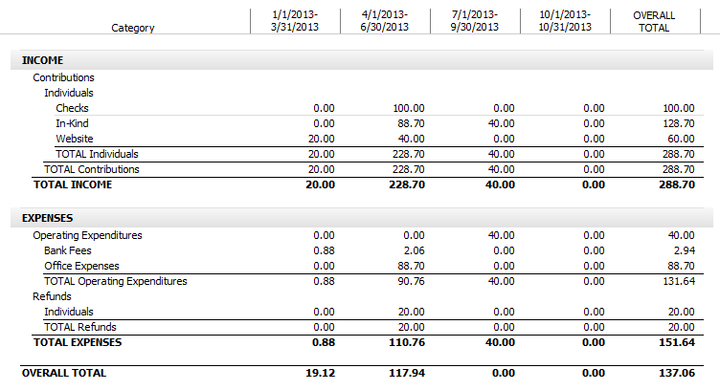

**Income vs. Expenses by Payee – YTD (Quarterly)** 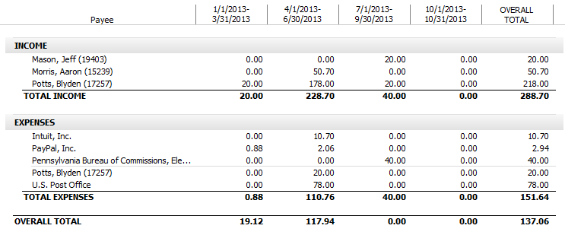

**Appendix A:   
Audit of Checking Account**